 | TeleNav, Inc. Ph: 408.245.3800  2975 San Ysidro Way Fax: 408.245.0238  Santa Clara, CA 95051

TeleNav Movies db schema

Version | Date of Issue | Remarks | Revised
1.0 | 10/24/08 | Initial Draft | Wei Lai
1.1 | 11/11/08 | Revise | Song Dongyi
1.2 | 12/08/08 | Revise | Song Dongyi
1.3 | 12/12/08 | Revise | Song Dongyi
1.4 | 12/26/08 | Revise | Song Dongyi
1.5 | 03/23/09 | Revise | Wei Lai
1.6 | 06/22/09 | Revise | Wei Lai

1 Purpose 3
2 Procedure for DB Change 3
3 Change History 3
4 Database Object (trigger, procedures ) 4
5 DB structure 4
5.1 Mysql schema 4
5.1.1 Add table movie 4
5.1.2 Add table theater 5
5.1.3 Add table schedule 5

Purpose
Purpose of this scoping document is to define Movies project.
Database name: MOVIES_DB
Account: MOVIESADMIN

Procedure for DB Change

Change History
Date | Table Changed | Reason | Requester
2008-10-24 | Initial |  | Wei Lai
2008-11-11 | Change column movie_director varchar (60) to varchar (120) in table MOVIE. |  | Song Dongyi
2008-11-11 | Add one column  movie_alt_film_id varchar (10) to table MOVIE. |  | Song Dongyi
2008-11-11 | Change column show_time varchar (60) to varchar (200) in table SCHEDULE. |  | Song Dongyi
2008-11-28 | Add new table MOVIEIMAGE (image_key, image_data).  Image_key varchar(40)  image_data (blog) |  | Song Dongyi
2008-11-27 | Change column vendor_id varchar (15) to varchar (30) in table MOVIE. |  | Song Dongyi
2008-12-4 | Add one column  vendor_name varchar (10)  to table SCHEDULE |  | Song Dongyi
2008-12-08 | Add two columns  quals varchar(200)  ticket_uri varchar(200) to table SCHEDULE |  | Song Dongyi
2008-12-24 | Change column vendor_id varchar(30) to varchar(230), movie_name varchar(40) to varchar(240) in table MOVIE |  | Song Dongyi
2009-3-23 | Add column MOVIE_RELEASE_DATE (Datetime) to table MOVIE |  | Wei Lai
2009-06-22 | Change length of theater name to 200 |  | Wei Lai

Database Object (triggers, procedures)

DB structure

Mysql schema
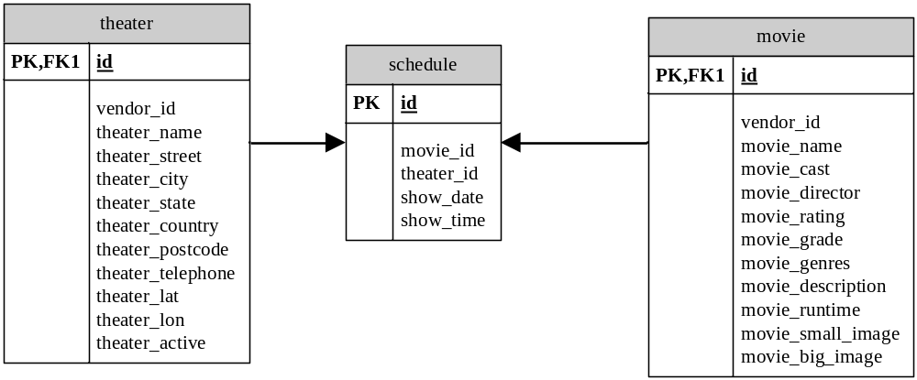

Add table movie
Name | Type | Default | Null? | Key | Index | Note
id | NUMBER(12) |  | NOT NULL | PK | YES | AUTO INCREMENT
vendor_id | VARCHAR(230) |  | NOT NULL |  |  | Id from vendor. Currently TMS, eg MV002344590000
movie_name | VARCHAR(240) |  | NOT NULL
movie_cast | VARCHAR(200) |  | NULL
movie_director | VARCHAR(120) |  | NULL
movie_rating | NUMERIC(2,1) |  | NULL |  |  | 0.5~4
movie_grade | VARCHAR(20) |  | NULL
movie_genres | VARCHAR(60) |  | NULL
movie_description | VARCHAR(400) |  | NULL
movie_runtime | VARCHAR(10) |  | NULL |  |  | 1H25M
movie_small_image | VARCHAR(100) |  | NULL
movie_big_image | VARCHAR(100) |  | NULL
movie_alt_film_id | VARCHAR(10) |  | NOT NULL
movie_release_date | DATETIME |  | NULL

Logic in this table:
Use to save movie information.
Load on this table
Insert: every morning about 9:00 PST
Delete: every morning about 9:00 PST
Query: Often.

Add table theater
Name | Type | Default | Null? | Key | Index | Note
id | NUMBER(12) |  | NOT NULL | PK | YES | AUTO INCREMENT
vendor_id | VARCHAR(15) |  | NOT NULL |  |  | Id from vendor. Currently TMS, eg AACIM
theater_name | VARCHAR(200) |  | NOT NULL
theater_street | VARCHAR(100) |  | NULL
theater_city | VARCHAR(50) |  | NULL
theater_state | VARCHAR(20) |  | NULL
theater_country | VARCHAR(20) |  | NULL
theater_postcode | VARCHAR(20) |  | NULL
theater_telephone | VARCHAR(20) |  | NULL
theater_lat | NUMERIC(9,6) |  | NOT NULL
theater_lon | NUMERIC(9,6) |  | NOT NULL
theater_active | NUMERIC (1) | 1 | NOT NULL |  |  | 1. Active 0. Inactive

Logic in this table:
Use to save theater information.
Load on this table
Insert: every morning about 9:00 PST
Delete: every morning about 9:00 PST
Query: Often.

Add table schedule
Name | Type | Default value | Null? | Key | Index | Note
id | NUMBER(12) |  | NOT NULL | PK | YES | AUTO INCREMENT
movie_id | NUMBER(12) |  | NOT NULL
theater_id | NUMBER(12) |  | NOT NULL
Show_date | DATETIME |  | NOT NULL |  |  | 2008-9-10
Show_time | VARCHAR(200) |  | NOT NULL |  |  | 21:30_12:30_....
vendor_name | VARCHAR(10) |  | NOT NULL
quals | VARCHAR(200) |  | NULL
ticket_uri | VARCHAR(200) |  | NULL

Logic in this table:
Use to save the schedule of the movies.
Load on this table
Insert: every morning about 9:00 PST
Delete: every morning about 9:00 PST
Query: Often.

Add table movieimage
Name | Type | Default value | Null? | Key | Index | Note
image_key | VARCHAR(40) |  | NOT NULL | PK | YES
image_data | BLOG |  | NULL

Logic in this table:
Use to save the images of the movies.
Load on this table
Insert and update once a day.
When the feed data is published, it will be parsed and insert into temporary table first. Then backup tables such as movie_20081209 will be created. All the feed will be copied to that backup table. When the process on all the three tables movie, theater and schedule are finished, the current table will be dropped and rename the temp table to enable the latest feed. There may be over 200,000 data in all. This will decrease the outage during feed and make sure the integrity of the data.
Query
There are only queries in the rest time.

